Harshil Jain
1024030824
DA assignment 2

Q1.
#include <iostream>
using namespace std;

int main() {
int n = 6;
int start[] = {1, 3, 0, 5, 8, 5};
int finish[] = {2, 4, 6, 7, 9, 9};

for(int i = 0; i < n - 1; i++) {
for(int j = i + 1; j < n; j++) {
if(finish[i] > finish[j]) {
int temp = finish[i];
finish[i] = finish[j];
finish[j] = temp;

temp = start[i];
start[i] = start[j];
start[j] = temp;
}
}
}

cout << "Selected activities: ";
int count = 1;
int lastFinish = finish[0];

cout << "(" << start[0] << "," << finish[0] << ") ";

for(int i = 1; i < n; i++) {
if(start[i] >= lastFinish) {
cout << "(" << start[i] << "," << finish[i] << ") ";
lastFinish = finish[i];
count++;
}
}

cout << "\nMaximum number of activities = " << count;
return 0;
}
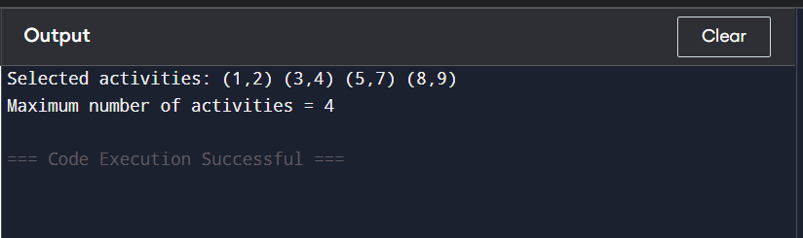

Q2.
#include <iostream>
using namespace std;

int main() {
int n;
cout << "Enter number of trains: ";
cin >> n;

int arr[20], dep[20];

cout << "Enter arrival times (HHMM format):\n";
for(int i = 0; i < n; i++)
cin >> arr[i];

cout << "Enter departure times (HHMM format):\n";
for(int i = 0; i < n; i++)
cin >> dep[i];

// Sort arrival times
for(int i = 0; i < n - 1; i++) {
for(int j = i + 1; j < n; j++) {
if(arr[i] > arr[j]) {
int t = arr[i];
arr[i] = arr[j];
arr[j] = t;
}
}
}

// Sort departure times
for(int i = 0; i < n - 1; i++) {
for(int j = i + 1; j < n; j++) {
if(dep[i] > dep[j]) {
int t = dep[i];
dep[i] = dep[j];
dep[j] = t;
}
}
}

int platforms = 1, maxPlatforms = 1;
int i = 1, j = 0;

while(i < n && j < n) {
if(arr[i] <= dep[j]) {
platforms++;
if(platforms > maxPlatforms)
maxPlatforms = platforms;
i++;
} else {
platforms--;
j++;
}
}

cout << "Minimum number of platforms required = " << maxPlatforms;
return 0;
}

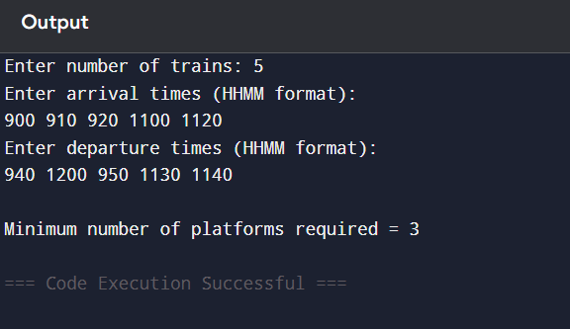

Q3.
#include <iostream>
using namespace std;

int main() {
int n, capacity;
cout << "Enter number of items: ";
cin >> n;

int value[20], weight[20];
float ratio[20];

for(int i = 0; i < n; i++) {
cout << "Enter value and weight of item " << i+1 << ": ";
cin >> value[i] >> weight[i];
ratio[i] = (float)value[i] / weight[i];
}

cout << "Enter knapsack capacity: ";
cin >> capacity;

// Sort by value/weight ratio
for(int i = 0; i < n - 1; i++) {
for(int j = i + 1; j < n; j++) {
if(ratio[i] < ratio[j]) {
float r = ratio[i]; ratio[i] = ratio[j]; ratio[j] = r;

int t = value[i]; value[i] = value[j]; value[j] = t;
t = weight[i]; weight[i] = weight[j]; weight[j] = t;
}
}
}

float totalValue = 0;

for(int i = 0; i < n; i++) {
if(capacity >= weight[i]) {
capacity -= weight[i];
totalValue += value[i];
} else {
totalValue += value[i] * ((float)capacity / weight[i]);
break;
}
}

cout << "Maximum value = " << (int)totalValue;
return 0;
}

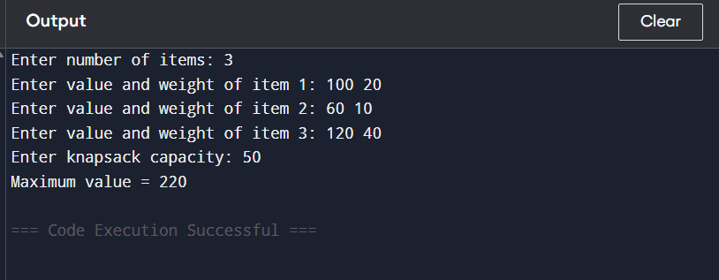

Q4.
#include <iostream>
using namespace std;

int main() {
int n;
cout << "Enter number of jobs: ";
cin >> n;

char job[20];
int deadline[20], profit[20];

for(int i = 0; i < n; i++) {
cout << "Enter job id, deadline and profit: ";
cin >> job[i] >> deadline[i] >> profit[i];
}

// Sort jobs by profit
for(int i = 0; i < n - 1; i++) {
for(int j = i + 1; j < n; j++) {
if(profit[i] < profit[j]) {
int t = profit[i]; profit[i] = profit[j]; profit[j] = t;
t = deadline[i]; deadline[i] = deadline[j]; deadline[j] = t;
char c = job[i]; job[i] = job[j]; job[j] = c;
}
}
}

int slot[20] = {0};
int totalProfit = 0;

cout << "Selected Jobs: ";

for(int i = 0; i < n; i++) {
for(int j = deadline[i] - 1; j >= 0; j--) {
if(slot[j] == 0) {
slot[j] = job[i];
totalProfit += profit[i];
cout << job[i] << " ";
break;
}
}
}

cout << "\nMaximum Profit = " << totalProfit;
return 0;
}

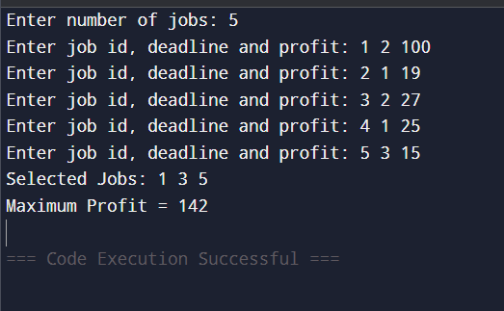

Q5.
#include <iostream>
using namespace std;

struct Node {
char c;
int f;
Node *l, *r;
};

Node* newNode(char c, int f) {
Node* n = new Node;
n->c = c;
n->f = f;
n->l = n->r = NULL;
return n;
}

int minIndex(Node* a[], int n) {
int m = 0;
for(int i = 1; i < n; i++)
if(a[i]->f < a[m]->f)
m = i;
return m;
}

void show(Node* t, int code[], int k) {
if(t->l) {
code[k] = 0;
show(t->l, code, k + 1);
}
if(t->r) {
code[k] = 1;
show(t->r, code, k + 1);
}
if(!t->l && !t->r) {
cout << t->c << " ";
for(int i = 0; i < k; i++)
cout << code[i];
cout << endl;
}
}

int main() {
int n;
cin >> n;

Node* a[20];

for(int i = 0; i < n; i++) {
char c;
int f;
cin >> c >> f;
a[i] = newNode(c, f);
}

int s = n;

while(s > 1) {
int i = minIndex(a, s);
Node* x = a[i];
a[i] = a[s - 1];
s--;

int j = minIndex(a, s);
Node* y = a[j];
a[j] = a[s - 1];
s--;

Node* z = newNode('#', x->f + y->f);
z->l = x;
z->r = y;

a[s] = z;
s++;
}

int code[20];
show(a[0], code, 0);

return 0;
}

